20BCS042 | Mohd Adil

Assignment 11

mysql> create database assignment11;

Query OK, 1 row affected (0.04 sec)

mysql> delimiter ]

mysql> SET GLOBAL log_bin_trust_function_creators = 1]

Query OK, 0 rows affected (0.01 sec)

**Q1. Write a SQL function and stored procedure for average of three numbers.**

**Function:**

mysql> create function 42CSavg3no(a int, b int,c int) returns int

-> begin

-> declare sum,avg int;

-> set sum = a + b + c;

-> set avg = sum/3;

-> return avg;

-> end]

Query OK, 0 rows affected (0.03 sec)

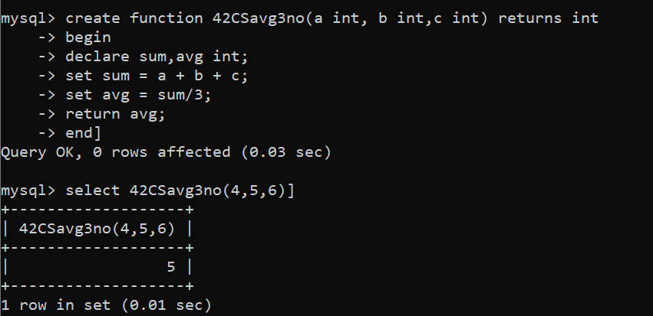

**Procedure:**

mysql> create procedure 42CSavg3no(In a int,In b int,In c int,Out t int)

-> begin

-> declare sum int;

-> set sum = a + b + c;

-> set t = sum/3;

-> end]

Query OK, 0 rows affected (0.01 sec)

mysql> call 42CSavg3no(4,5,6,@avg)]

Query OK, 0 rows affected (0.01 sec)

mysql> select @avg]

+------+

| @avg |

+------+

| 5 |

+------+

1 row in set (0.00 sec)

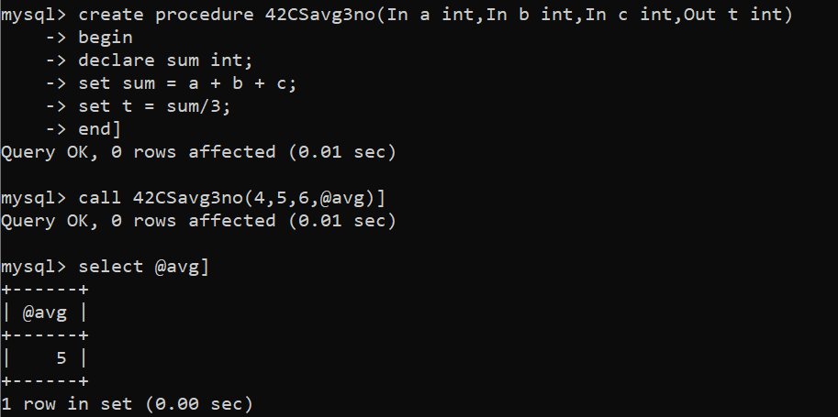

**Q2. Write a SQL function and stored procedure to calculate factorial.**

**Function:**

mysql> create function 42CSfactorial(n int) returns int

-> begin

-> declare f,i int default 1;

-> myloop:loop

-> if i>n then

-> leave myloop;

-> else

-> set f = f*i;

-> set i = i + 1;

-> iterate myloop;

-> end if;

-> end loop;

-> return f;

-> end]

Query OK, 0 rows affected (0.01 sec)

mysql> select 42CSfactorial(5)]

+------------------+

| 42CSfactorial(5) |

+------------------+

| 120 |

+------------------+

1 row in set (0.00 sec)

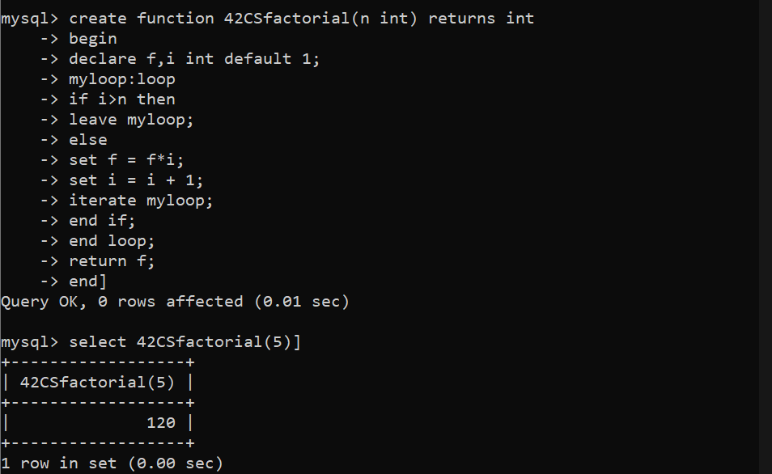

**Procedure:**

mysql> create procedure 42CSfactorial(In n int,Out fact int)

-> begin

-> declare f,i int default 1;

-> myloop:loop

-> if i>n then

-> leave myloop;

-> else

-> set f = f*i;

-> set i = i + 1;

-> iterate myloop;

-> end if;

-> end loop;

-> set fact = f;

-> end]

Query OK, 0 rows affected (0.01 sec)

mysql> call 42CSfactorial(5,@factorial5)]

Query OK, 0 rows affected (0.00 sec)

mysql> select @factorial5]

+-------------+

| @factorial5 |

+-------------+

| 120 |

+-------------+

1 row in set (0.00 sec)

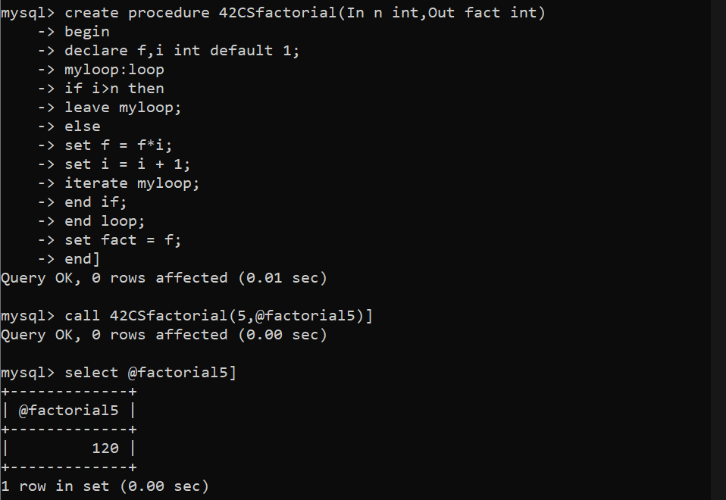

**Q3. Write a SQL function and stored procedure to print Fibonacci series up to n terms and its sum.**

**Function:**

mysql> create function 42CSfibonacci(n int) returns varchar(1000)

-> begin

-> declare i int default 3;

-> declare a,temp int default 0;

-> declare b,sum int default 1;

-> declare str varchar(1000);

-> set str = CAST(a as char(2));

-> set str = CONCAT(str," ");

-> myloop:loop

-> if i>n then

-> leave myloop;

-> else

-> set temp = a + b;

-> set a = b;

-> set b = temp;

-> set i = i + 1;

-> set sum = sum + temp;

-> set str = CONCAT(str,CAST(a as char(2)));

-> set str = CONCAT(str, " ");

-> end if;

-> end loop;

-> set str = CONCAT(str,CAST(b as char(2)));

-> set str = CONCAT(str, " and sum = ");

-> set str = CONCAT(str,CAST(sum as char(3)));

-> return str;

-> end]

Query OK, 0 rows affected (0.01 sec)

mysql> select 42CSfibonacci(6)]

+--------------------------+

| 42CSfibonacci(6) |

+--------------------------+

| 0 1 1 2 3 5 and sum = 12 |

+--------------------------+

1 row in set (0.00 sec)

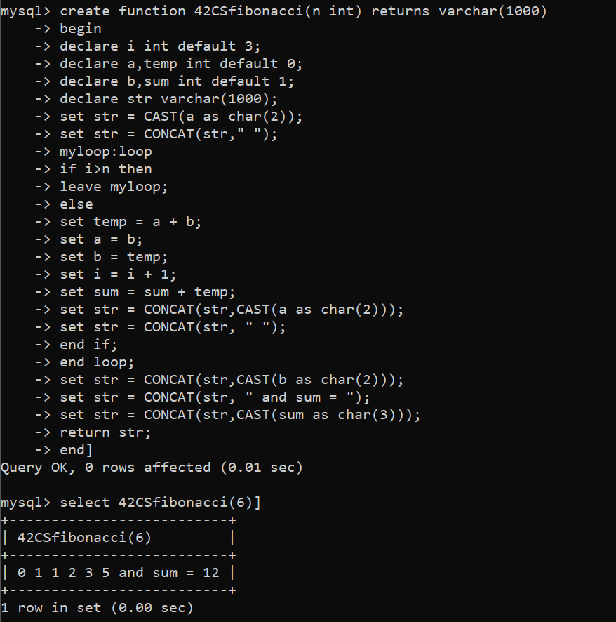

**Procedure:**

mysql> create procedure 42CSfibonacci(In n int,Out retStr varchar(1000))

-> begin

-> declare i int default 3;

-> declare a,temp int default 0;

-> declare b,sum int default 1;

-> declare str varchar(1000);

-> set str = CAST(a as char(2));

-> set str = CONCAT(str," ");

-> myloop:loop

-> if i>n then

-> leave myloop;

-> else

-> set temp = a + b;

-> set a = b;

-> set b = temp;

-> set i = i + 1;

-> set sum = sum + temp;

-> set str = CONCAT(str,CAST(a as char(2)));

-> set str = CONCAT(str, " ");

-> end if;

-> end loop;

-> set str = CONCAT(str,CAST(b as char(2)));

-> set str = CONCAT(str, " and sum = ");

-> set str = CONCAT(str,CAST(sum as char(3)));

-> set retstr = str;

-> end]

Query OK, 0 rows affected (0.01 sec)

mysql> call 42CSfibonacci(6,@series6)]

Query OK, 0 rows affected (0.00 sec)

mysql> select @series6]

+--------------------------+

| @series6 |

+--------------------------+

| 0 1 1 2 3 5 and sum = 12 |

+--------------------------+

1 row in set (0.00 sec)

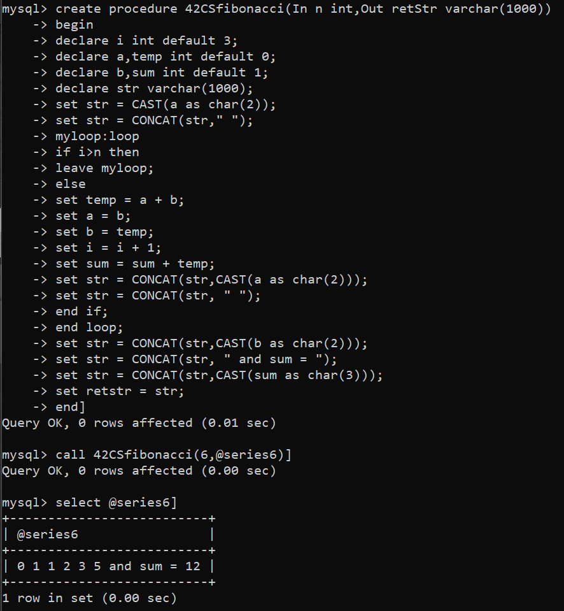

**Q4. Write a SQL function and stored procedure to calculate age.**

**Function:**

mysql> create function 42CScalcAge(dat date) returns varchar(25)

-> begin

-> declare curDate date default CURRENT_DATE();

-> declare tempDate date;

-> declare year,month,date int default 0;

-> declare str varchar(25) default "";

-> set year = TIMESTAMPDIFF(YEAR,dat,curDate);

-> set month = TIMESTAMPDIFF(MONTH,dat,curDate);

-> set month = month - (year*12);

-> set tempDate = DATE_ADD(dat,INTERVAL year YEAR);

-> set tempDate = DATE_ADD(tempDate,INTERVAL month MONTH);

-> set date = DATEDIFF(curDate,tempDate) + 1;

-> set str = CONCAT(str,CAST(year as char(2)));

-> set str = CONCAT(str,"Y ");

-> set str = CONCAT(str,CAST(month as char(2)));

-> set str = CONCAT(str,"M ");

-> set str = CONCAT(str,CAST(date as char(2)));

-> set str = CONCAT(str,"D ");

-> return str;

-> end]

Query OK, 0 rows affected (0.01 sec)

mysql> select 42CScalcAge('1992-05-11')]

+---------------------------+

| 42CScalcAge('1992-05-11') |

+---------------------------+

| 29Y 11M 19D |

+---------------------------+

1 row in set (0.00 sec)

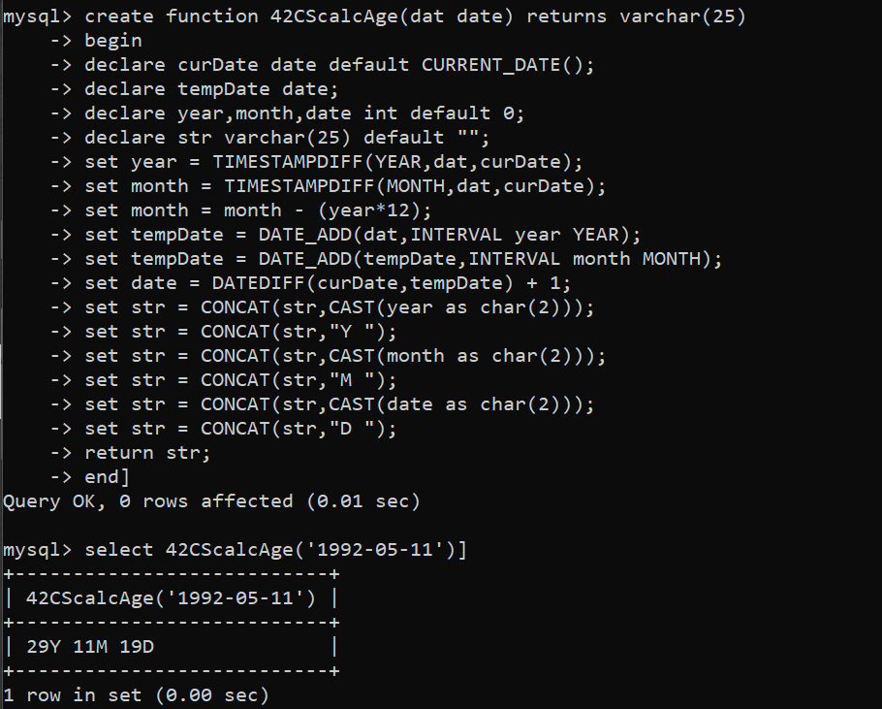

**Procedure:**

mysql> create procedure 42CScalcAge(In dat date,Out retStr varchar(25))

-> begin

-> declare curDate date default CURRENT_DATE();

-> declare tempDate date;

-> declare year,month,date int default 0;

-> declare str varchar(25) default "";

-> set year = TIMESTAMPDIFF(YEAR,dat,curDate);

-> set month = TIMESTAMPDIFF(MONTH,dat,curDate);

-> set month = month - (year*12);

-> set tempDate = DATE_ADD(dat,INTERVAL year YEAR);

-> set tempDate = DATE_ADD(tempDate,INTERVAL month MONTH);

-> set date = DATEDIFF(curDate,tempDate) + 1;

-> set str = CONCAT(str,CAST(year as char(2)));

-> set str = CONCAT(str,"Y ");

-> set str = CONCAT(str,CAST(month as char(2)));

-> set str = CONCAT(str,"M ");

-> set str = CONCAT(str,CAST(date as char(2)));

-> set str = CONCAT(str,"D ");

-> set retStr = str;

-> end]

Query OK, 0 rows affected (0.01 sec)

mysql> call 42CScalcAge('1992-05-11',@age)]

Query OK, 0 rows affected (0.01 sec)

mysql> select @age]

+--------------+

| @age |

+--------------+

| 29Y 11M 19D |

+--------------+

1 row in set (0.00 sec)

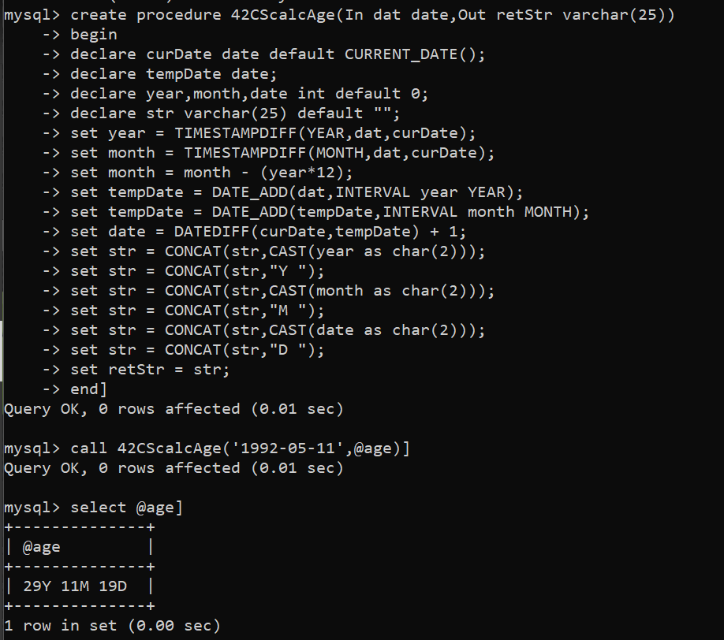

**Q5. Write a SQL function and stored procedure to count the total number of employees table.**

**Function:**

mysql> create function 42CStotalNoEmployees() returns int

-> begin

-> declare s int;

-> select count(*) from employee into s;

-> return s;

-> end]

Query OK, 0 rows affected (0.01 sec)

mysql> select 42CStotalNoEmployees()]

+------------------------+

| 42CStotalNoEmployees() |

+------------------------+

| 8 |

+------------------------+

1 row in set (0.01 sec)

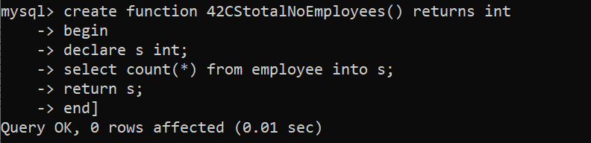

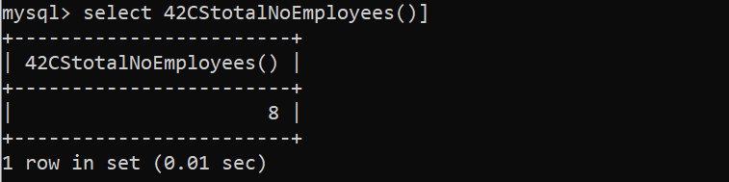

**Procedure:**

mysql> create procedure 42CStotalNoEmployees(Out count int)

-> begin

-> declare s int;

-> select count(*) from employee into s;

-> set count = s;

-> end]

Query OK, 0 rows affected (0.01 sec)

mysql> call 42CStotalNoEmployees(@result)]

Query OK, 1 row affected (0.01 sec)

mysql> select @result]

+---------+

| @result |

+---------+

| 8 |

+---------+

1 row in set (0.00 sec)

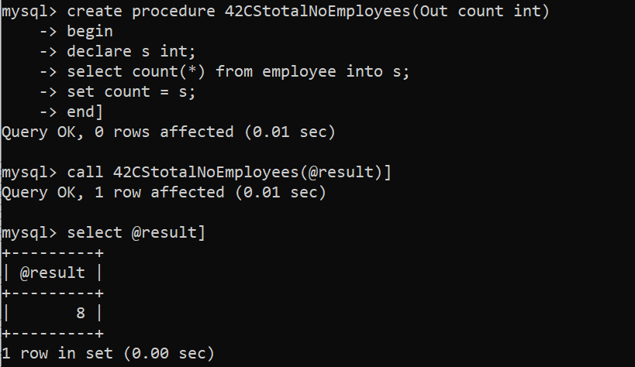

**Q6. Write a SQL function and stored procedure to calculate the budget of the department.**

**Function:**

mysql> create function 42CScalcBudget(dept varchar(30)) returns int

-> begin

-> declare deptnumber varchar(5);

-> declare budget int default 0;

-> select Dnumber from department where Dname = dept into deptnumber;

-> select sum(salary) from employee where Dno = deptnumber into budget;

-> return budget;

-> end]

Query OK, 0 rows affected (0.01 sec)

mysql> select 42CScalcBudget('Research')]

+----------------------------+

| 42CScalcBudget('Research') |

+----------------------------+

| 133000 |

+----------------------------+

1 row in set (0.01 sec)

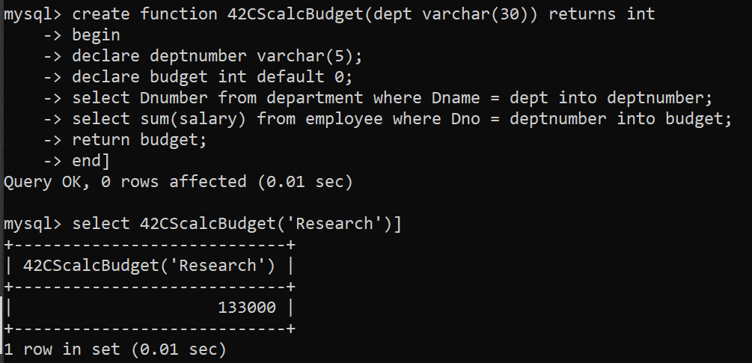

**Procedure:**

mysql> create procedure 42CScalcBudget(In dept varchar(30),Out budget int)

-> begin

-> declare deptnumber varchar(5);

-> declare sumSal int default 0;

-> select Dnumber from department where Dname = dept into deptnumber;

-> select sum(salary) from employee where Dno = deptnumber into sumSal;

-> set budget = sumSal;

-> end]

Query OK, 0 rows affected (0.01 sec)

mysql> call 42CScalcBudget('Research',@Budget)]

Query OK, 1 row affected (0.00 sec)

mysql> select @Budget]

+---------+

| @Budget |

+---------+

| 133000 |

+---------+

1 row in set (0.00 sec)

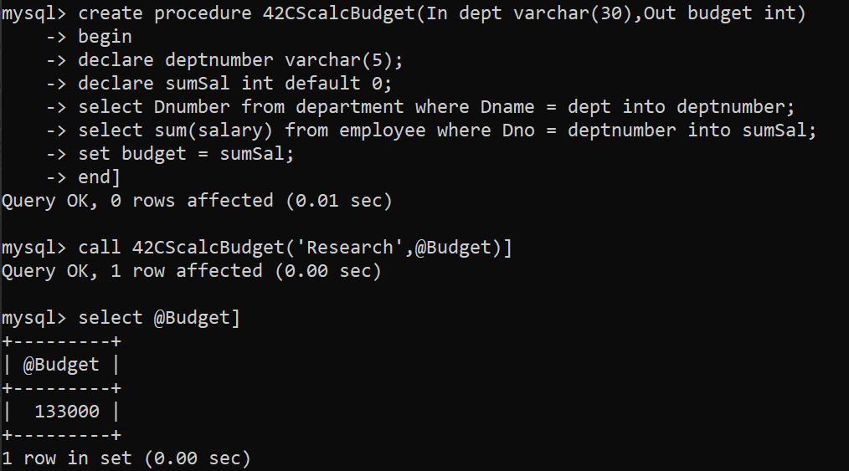

**Q7. Write a SQL function and stored procedure to print the following message.**

**Function:**

mysql> create function 42CSprintMsg(name varchar(50)) returns varchar(100)

-> begin

-> declare msg varchar(100) default "Hello ";

-> set msg = CONCAT(msg,name);

-> set msg = CONCAT(msg," How are you?");

-> return msg;

-> end]

Query OK, 0 rows affected (0.01 sec)

mysql> select 42CSprintMsg('Mohd Adil')]

+------------------------------+

| 42CSprintMsg('Mohd Adil') |

+------------------------------+

| Hello Mohd Adil How are you? |

+------------------------------+

1 row in set (0.01 sec)

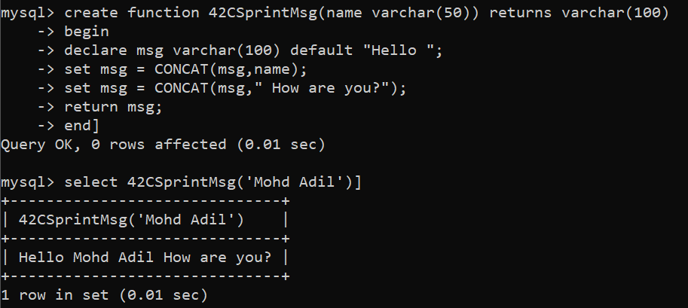

**Procedure:**

mysql> create procedure 42CSprintMsg(In name varchar(50),Out message varchar(100))

-> begin

-> declare msg varchar(100) default "Hello ";

-> set msg = CONCAT(msg,name);

-> set msg = CONCAT(msg," How are you?");

-> set message = msg;

-> end]

Query OK, 0 rows affected (0.01 sec)

mysql> call 42CSprintMsg('Mohd Adil',@message)]

Query OK, 0 rows affected (0.00 sec)

mysql> select @message]

+------------------------------+

| @message |

+------------------------------+

| Hello Mohd Adil How are you? |

+------------------------------+

1 row in set (0.00 sec)

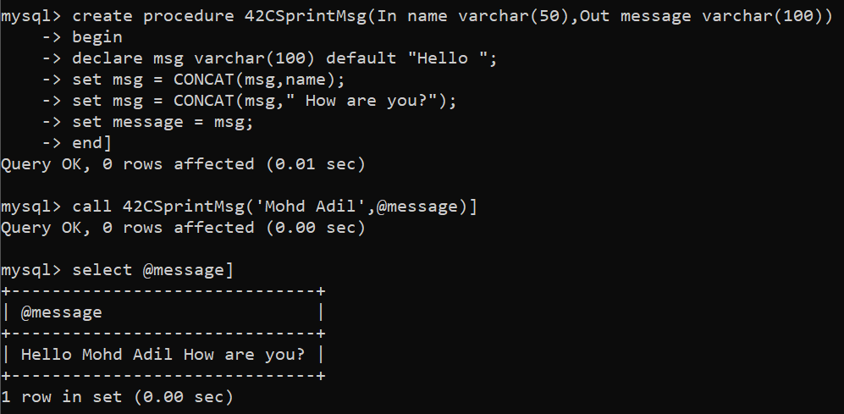

**1.Employee**

mysql> create table Employee (

-> Eid varchar (5) primary key,

-> Ename varchar(50),

-> Esal varchar(6));

Query OK, 0 rows affected (0.10 sec)

**2.LogTable**

mysql> create table LogTable(

-> User varchar(50),

-> Operation varchar(20),

-> Time varchar(20),

-> Peid varchar(5),

-> Pename varchar(50),

-> Pesal varchar(6),

-> Neid varchar(5),

-> Nename varchar(50),

-> Nesal varchar(6));

Query OK, 0 rows affected (0.04 sec)

**Insert Trigger:**

mysql> delimiter ]

mysql> create trigger insertTrig after insert on Employee for each row

-> begin

-> insert into LogTable values (user(),'Insert',now(),'-','-','-',new.Eid,new.Ename,new.Esal);

-> end ]

Query OK, 0 rows affected (0.03 sec)

mysql> insert into Employee

-> values ('E0001','Mohd Adil','79901') ]

Query OK, 1 row affected (0.01 sec)

mysql> select * from LogTable]

+----------------+-----------+---------------------+------+--------+-------+-------+-----------+-------+

| User | Operation | Time | Peid | Pename | Pesal | Neid | Nename | Nesal |

+----------------+-----------+---------------------+------+--------+-------+-------+-----------+-------+

| root@localhost | Insert | 2022-04-30 15:01:47 | - | - | - | E0001 | Mohd Adil | 79901 |

+----------------+-----------+---------------------+------+--------+-------+-------+-----------+-------+

1 row in set (0.00 sec)

**Update Trigger:**

mysql> create trigger updateTrig after update on Employee for each row

-> begin

-> insert into LogTable

-> values(user(),'Update',now(),old.Eid,old.Ename,old.Esal,new.Eid,new.Ename,new.Esal);

-> end ]

Query OK, 0 rows affected (0.01 sec)

mysql> update Employee set Esal='10010' where Eid='E0001' ]

Query OK, 1 row affected (0.02 sec)

Rows matched: 1 Changed: 1 Warnings: 0

mysql> select * from logTable]

+----------------+-----------+---------------------+-------+---------+-------+-------+-----------+-------+

| User | Operation | Time | Peid | Pename | Pesal | Neid | Nename | Nesal |

+----------------+-----------+---------------------+-------+---------+-------+-------+-----------+-------+

| root@localhost | Insert | 2022-04-30 15:01:47 | - | - | - | E0001 | Mohd Adil | 79901 |

| root@localhost | Update | 2022-04-30 15:05:16 | E0001 | Mohd Adil | 79901 | E0001 | Mohd Adil | 10010 |

+----------------+-----------+---------------------+-------+---------+-------+-------+-----------+-------+

2 rows in set (0.00 sec)

**Delete Trigger:**

mysql> create trigger deleteTrig after delete on Employee for each row

-> begin

-> insert into LogTable

-> values (user(),'Delete',now(),old.Eid,old.Ename,old.Esal,'-','-','-');

-> end ]

Query OK, 0 rows affected (0.01 sec)

mysql> delete from Employee where Eid='E0001' ]

Query OK, 1 row affected (0.01 sec)

mysql> select * from logTable]

+----------------+-----------+-------------------+-------+-----------+-------+-------+-----------+-------+

| User | Operation | Time | Peid | Pename | Pesal | Neid | Nename | Nesal |

+----------------+-----------+-------------------+-------+-----------+-------+-------+-----------+-------+

| root@localhost | Insert | 2022-04-30 15:01:47 | - | - | - | E0001 | Mohd Adil | 79901 |

| root@localhost | Update | 2022-04-30 15:05:16 | E0001 | Mohd Adil | 79901 | E0001 | Mohd Adil | 10010 |

| root@localhost | Delete | 2022-04-30 15:08:24 | E0001 | Mohd Adil | 10010 | - | - | - |

+----------------+-----------+-------------------+-------+-----------+-------+-------+-----------+-------+

3 rows in set (0.00 sec)

**Cursor**

mysql> select * from employee]

+-------+-------+-------+

| Eid | Ename | Esal |

+-------+-------+-------+

| E0002 | ABC | 30000 |

| E0003 | XYZ | 40000 |

| E0004 | DEF | 50000 |

+-------+-------+-------+

3 rows in set (0.00 sec)

mysql> create procedure mypro(out s varchar(6))

-> begin

-> declare f int default 1;

-> declare str longtext default "";

-> declare cur cursor for select Esal from Employee ;

-> declare continue handler for not found set f=0;

-> open cur;

-> myloop:loop

-> fetch cur into s;

-> if f = 0 then

-> leave myloop;

-> else

-> set str = CONCAT(str," ",s);

-> end if;

-> end loop;

-> close cur;

-> select str;

-> end ]

Query OK, 0 rows affected (0.01 sec)

mysql> call mypro(@s)]

+--------------------+

| str |

+--------------------+

| 30000 40000 50000 |

+--------------------+

1 row in set (0.00 sec)

Query OK, 0 rows affected (0.01 sec)

Thank You